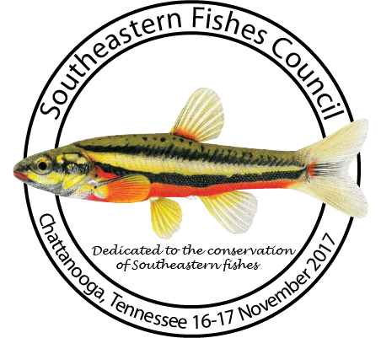
1st Call for Abstracts
2017 Southeastern Fishes Council Meeting
Chattanooga, Tennessee

The annual meeting of the Southeastern Fishes Council will be held in Chattanooga, Tennessee on Thursday and Friday, November 16-17, 2017. Additionally, an educational field trip to a local stream will be offered on Saturday, November 18.

The meeting will include two days of oral presentation sessions and a poster session on Thursday evening at the Tennessee Aquarium’s River Journey. We will also offer a lightning talk session of 5-minute talks (strictly enforced!) with no questions on Thursday. Titles and abstracts must be submitted for all presentations by Monday October 16, 2017 at http://sefishescouncil.org/abstracts/.

Registration is open with EARLY registration ending October 28th at midnight!
Following the poster session there will be an auction at the DoubleTree Hotel. Please look around for duplicate publications (fish or otherwise) plus anything “fishy” that you think we might be able to raise a couple of dollars from in an auction.

Those interested will be able to tour the new Tennessee Aquarium Conservation Institute at an open house on Wednesday, November 15 from 4-6 pm. This 14,000 sq. ft. freshwater field station is located four miles north of the Tennessee Aquarium along the Tennessee River (35.08139, -85.33704).

Registration Rates:
- Member Early Registration – $125.00 (Must be a dues paid member prior to registration, renew online)
- Member Late Registration – $175.00
- Non Member Early Registration – $175.00 (If you would like to join and get the Regular Member Rate click here: http://sfc8.wildapricot.org/page-1734727)
- Non Member Late Registration – $225.00
- Student Member Early Registration – $50.00
- Student Member Late Registration – $75.00
- Student Non Member Early Registration – $100.00 (If you would like to join and get the Student Member rate click here: http://sfc8.wildapricot.org/page-1734727)
- Student Non Member Late Registration – $150.00

Accommodations: DoubleTree Hotel, 407 Chestnut Street, Chattanooga, TN 37402. The Southeastern Fishes Council has 75 rooms reserved at the DoubleTree Hotel for Wednesday and Thursday nights and 15 rooms for Friday night for $129.00/night plus taxes (17.25%). Parking on site is $15.00/night for overnight guests and $11.00/day for meeting attendees. Rooms must be reserved by 18 October 2017 to guarantee availability. There are three ways to reserve rooms:
1. Call the hotel directly at (423) 756-5150. Provide the front desk the arrival date and group name-TNACI-SE Fishes.
2. Copy and paste the URL listed below into your web browser and enter the arrival and departure dates to begin the reservation process: http://doubletree.hilton.com/en/dt/groups/personalized/C/CHACHDT-TNC-20171115/index.jhtml
3. Go to www.chattanooga.doubletree.com. Enter your arrival date and departure date and then click on “Add special rate codes.” In the “Group code” field, enter your group code, which is TNC. The group information will pull up and you will continue the reservation process.

